Installation Guide – Outdoor System
(S008A, S009A) – Garden Set & Lawn Set

- Refer to the installation diagram to have idea of the sequence the joints should be connected. It is recommended that the pieces be identified and placed in the same order for first time installers. After you have fully identified all the parts and sequence they should be fitted, you may begin the installation.

- Shut off the water mains.

- Remove the tap and proceed with the installation by putting the pieces together in the same sequence as in the installation diagram.

The following should be noted:
  - Wrap PTFE tapes (white) on the threaded part of the joint.
  - Put the threaded pieces together. In the event there is little resistance when you put the threaded pieces together (loose), more tape should be added until some resistance is felt when screwing the pieces together.
  - If there is a rubber washer in between joints, it is not necessary to wrap the joints with PTFE tapes (white).
  - After installing the timer and the valve, test for leaks by turning on the water mains. If there is no leaks then proceed to step 4, otherwise you will need to repeat from step 2.

- Insert batteries into the timer. You may not operate it on manual open and shut. Refer to the timer installation manual for programming the timer.

Ensure you complete the following steps:
  - Install the batteries (use alkali batteries).
  - Set the clock (min, hour and day).
  - Set the programs (ensure that there are complete with opening and closing time.). Make sure you do not have incomplete programs e.g. open without close or close without open.
  - Set the timer on auto mode (ensure the valve upstream the timer is in open position).
  - Lock the screen to prevent accidental alteration of settings.

- Connect the pieces below the timer.

- Connect the tubes to where your plants are located and require water.

The following should be noted when connecting PE tube joints
  - Put the tube through the cap.
  - Put on the tube seal (white piece) at the end of the tube with 0.5 cm of the tube end protruding through.
  - Place the rubber ring on the end of the tube.
  - Push the tube and the rubber ring into joint and turn the cap onto the joint. Use a pipe wrench to tighten the cap.

- Pin the tubes to the ground.

- Perform leak test by turning on the water supply and the timer (manual ON). Ensure that all tube ends are temporarily fitted with end caps or valve in order to pressure up the line. If there are no leaks at the joints, then proceed to 9; otherwise attend to the affected joints until there is no leak is found.

- Dig a trench 5cm wide and 5cn deep. Place the 20mm hose into the trench.

- Installation of water dispensing parts:

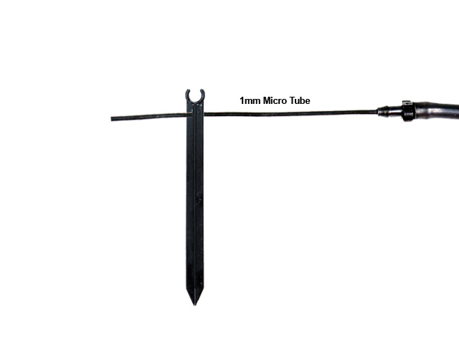

  - Micro tube
    - Punch a hole in the 20mm hose at the location where water is required using the hole puncher provided.
    - Wrap PTFE tape around the neck of the micro-tube joint.
    - Grip the joint with a pair of pliers and insert it into the hole.
    - Put the other end of the 1 mm tube into the hole of the tube support.
    - Stick the tube support into the pot.
    - You may connect a 4mm line in iii and then connect several 1 mm tubes to the 4 mm lines.

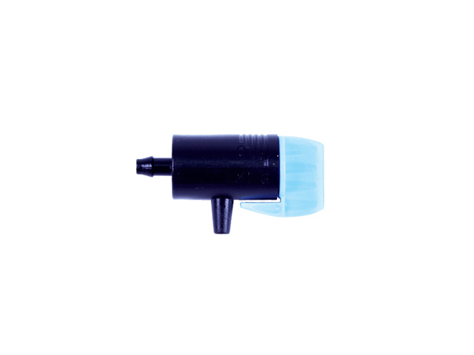

  - Adjustable Dripper
    - Perform step 10a (i to iii).
    - Cut a section of the 4 mm hose (to the length desired).
    - Heat the end of the 4 mm hose with a candle or lighter.
    - Slip one end into the 4mm joint previously inserted into the 20mm tube and the other end into the dripper.
    - Place the dripper on the dripper support.
    - Stick the dripper support into the pot.
    - Turn on the dripper (to readjust when the whole system is completed.).

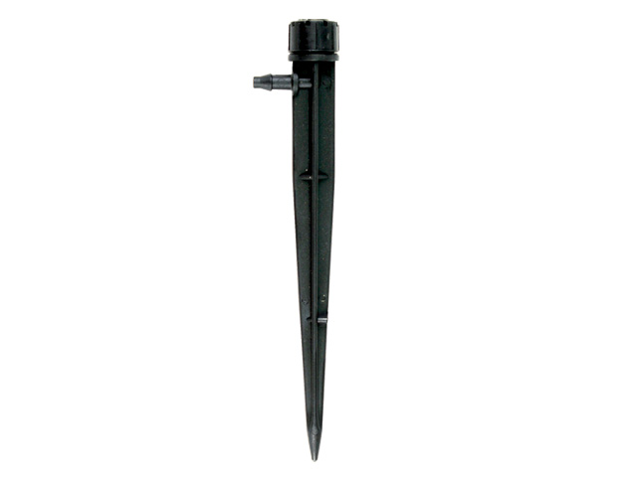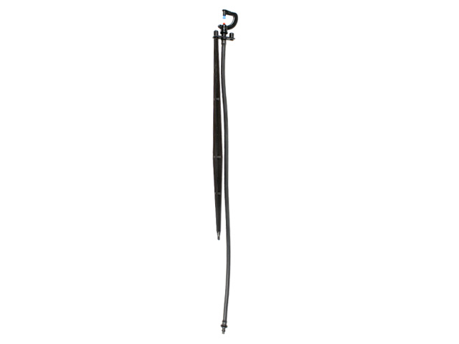

  - Coco (shrub) Sprinkler and Stand Impact Misting Sprinkler
    - Perform step 10a (i to iii).
    - Perform 10b (iii to iv).
    - Stick the sprinkler where watering is required.

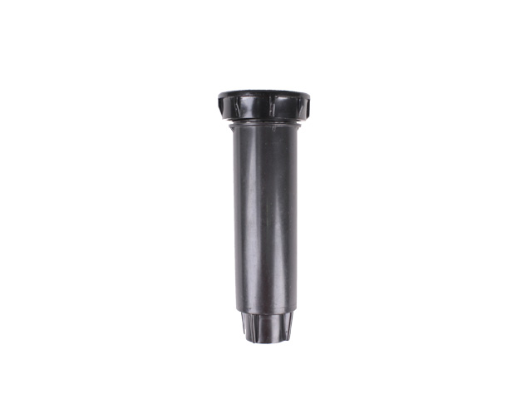

  - Pop-up Sprinkler
    - Connect the trumpet joint to the 20mm hose.
    - Place the trumpet joint into a whole deep enough to accommodate it (about 25 to 30 cm deep).
    - Tape the threaded joint.
    - Screw on the pop- up sprinkler into the trumpet joint. Leave at least 1 turn.
    - Adjust the spray angle (from top of sprinkler).
    - Adjust the sprinkler body to correct the direction of spray.
Installation Guide – Balcony / Patio System
(S004A) - Balcony / Patio Set

- Refer to the installation diagram to have idea of the sequence the joints should be connected. It is recommended that the pieces be identified and placed in the same order for first time installers. After you have fully identified all the parts and sequence they should be fitted, you may begin the installation.

- Shut off the water mains.

- Remove the tap and proceed with the installation by putting the pieces together in the same sequence as in the installation diagram.

The following should be noted:
- Wrap PTFE tapes (white) on the threaded part of the joint.
- Put the threaded pieces together. In the event there is little resistance when you put the threaded pieces together (loose), more tape should be added until some resistance is felt when screwing the pieces together.
- If there is a rubber washer in between joints, it is not necessary to wrap the joints with PTFE tapes (white).
- After installing the timer and the valve, test for leaks by turning on the water mains. If there is no leaks then proceed to step 4, otherwise you will need to repeat from step 2.

- Insert batteries into the timer. You may not operate it on manual open and shut. Refer to the timer installation manual for programming the timer.

Ensure you complete the following steps:
- Install the batteries (use alkali batteries)
- Set the clock (min, hour and day)
- Set the programs (ensure that there are complete with opening and closing time.). Make sure you do not have incomplete programs e.g. open without close or close without open.
- Set the timer on auto mode (ensure the valve upstream the timer is in open position)
- Lock the screen to prevent accidental alteration of settings.

- Connect the pieces below the timer.

- Insert the 4 mm tubes into the manifold caps
- Do not pull the 4mm tubes out of the cap. Doing so will damage the grip mechanism.

- Pin the 4mm tubes to the wall using the wall pegs provided. Cable ties may be used if the tube runs up a pole.

- Perform leak test by turning on the water supply and the timer (manual ON). Turn the manifold valve to OFF. If there are no leaks at the joints, then proceed to 9; otherwise attend to the affected joints until there is no leak is found.

- Installation of water dispensing parts

  - Micro Tube
- Cut the 4mm tubing where water is needed.
- Heat up the 2 ends (resulting from the cut) over a candle or lighter. Insert a “4mm T joint” into the 2 opposite ends.
- Cut a small section of 4mm tube 1-2 cm long. Heat up both ends with candle or cigarette lighter. Insert one end into the T joint and the other into the 4mm straight joint with the 1mm micro tube.
- Put the other end of the 1 mm tube into the hole of the tube support.
- Stick the tube support into the pot.
- You may connect a 4mm line in iii and then connect several 1 mm tubes to the 4 mm lines.

- Adjustable Dripper
- Perform step 9a (i to ii).
- Cut a section of the 4 mm hose (to the length desired).
- Heat the end of the 4 mm hose with a candle or lighter.
- Slip one end into the 4mm joint previously inserted into the 20mm tube and the other end into the dripper.
- Place the dripper on the dripper support.
- Stick the dripper support into the pot.
- Turn on the dripper (to readjust when the whole system is completed.).

Installation Guide - Gravity System
(S005A, S007A) – Balcony / Patio Set with a Tank & Fertigation Set with a Tank

- Refer to the installation diagram to have idea of the sequence the joints should be connected. It is recommended that the pieces be identified and placed in the same order for first time installers. After you have fully identified all the parts and sequence they should be fitted, you may begin the installation.

- Install the wall bracket or place the tank on a table or cupboard where the height is higher that the highest pot.

- Ensure the tank connector is tightly locked on by turning it. If it rotates, further tightening is required.

- Proceed with the installation by putting the pieces together in the same sequence as in the installation diagram.

The following should be noted:
- Wrap PTFE tapes (white) on the threaded part of the joint.
- Put the threaded pieces together. In the event there is little resistance when you put the threaded pieces together (loose), more tape should be added until some resistance is felt when screwing the pieces together.
- If there is a rubber washer in between joints, it is not necessary to wrap the joints with PTFE tapes (white).
- After installing the timer and the valve, test for leaks by filling the tank with water. If there is no leaks then proceed to step 4, otherwise you will need to repeat from step 3.

- Insert batteries into the timer. You may not operate it on manual open and shut. Refer to the timer installation manual for programming the timer.

Ensure you complete the following steps:
- Install the batteries (use alkali batteries).
- Set the clock (min, hour and day).
- Set the programs (ensure that there are complete with opening and closing time.). Make sure you do not have incomplete programs e.g. open without close or close without open.
- Set the timer on auto mode (ensure the valve upstream the timer is in open position).
- Lock the screen to prevent accidental alteration of settings.

- Connect the pieces below the timer.

- Insert the 4 mm tubes into the manifold caps
- Do not pull the 4mm tubes out of the cap. Doing so will damage the grip mechanism.

- Pin the 4mm tubes to the wall using the wall pegs provided. Cable ties may be used if the tube runs up a pole. Or hide it under the carpet.

- Installation of water dispensing parts

- Micro Tube
  - Cut the 4mm tubing where water is needed.
  - Heat up the 2 ends (resulting from the cut) over a candle or lighter. Insert a “4mm T joint” into the 2 opposite ends.
  - Cut a small section of 4mm tube 1-2 cm long. Heat up both ends with candle or cigarette lighter. Insert one end into the T joint and the other into the 4mm straight joint with the 1mm micro tube.
  - Put the other end of the 1 mm tube into the hole of the tube support.
  - Stick the tube support into the pot.
  - You may connect a 4mm line in iii and then connect several 1 mm tubes to the 4 mm lines.

- Adjustable Dripper
  - Perform step 8a (i to ii).
- Cut a section of the 4 mm hose (to the length desired).
- Heat the end of the 4 mm hose with a candle or lighter.
- Slip one end into the 4mm joint previously inserted into the 20mm tube and the other end into the dripper.
- Place the dripper on the dripper support.
- Stick the dripper support into the pot.
- Turn on the dripper (to readjust when the whole system is completed.).

- Create a goof plug by connecting the opposite end to both ends of a 6cm long 4mm tube. Plug the remaining end to the end of the 4 mm hose.

IMPORTANT
- To ensure that the system works, the tube must be free of air bubbles. Simply flush the 4 mm tube by removing the goof plug.

- Replace the goof plug when there are no more air bubbles.

- ENSURE that the micro tube and dripper outlet is always above the 4mm main hose to prevent water from draining when the timer is off.

- All main line 4 mm tubes must be at the same level.

